Physical Science SOL Review

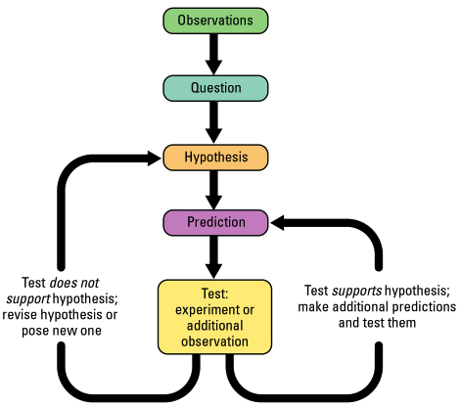
Compare – Noting the SIMILARITIES in two or more objects
Contrast - Noting the DIFFERENCES in two or more objects
Control – The standard used to compare with the outcome of a test
Data – Recorded observations and measurements (Qualitative and Quantitative)
Density – Measure of how much mass is contained in a given volume of objects
Dependent Variable – What is measured in an experiment: The response to the independent variable. (Data…Dependent!)
Independent Variable – The factor that is changed in an experiment
Graph – Diagram that shows the relationship of one variable to another
Hypothesis – A prediction that can be tested, based on qualitative and quantitative data that can be tested!
Inference – An attempt to explain or interpret observations
Law – Scientific theory that has been tested many times and is generally accepted as true
Mass – Measure of the amount of a matter in an object
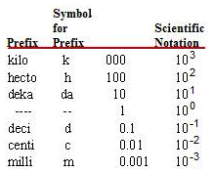
Qualitative – Describes something using only words. Qualities – based on your senses (sight, smell, touch, sound, etc.)
Quantitative – describing how much of something there is using Numbers… Quantity
Scientific Method – The systematic approach to problem solving.
It’s okay to be wrong!!! Figure out what went wrong and try again.
Sequence – An arrangement of things or events in a particular order
Theory – An explanation of things base on many observations
Variable – The factor tested in an experiment
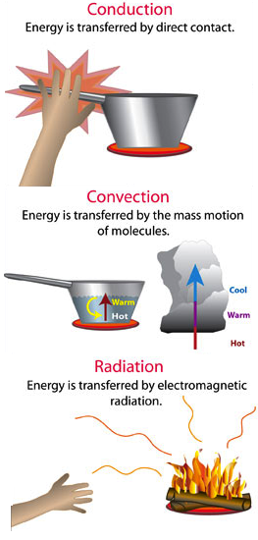
Volume – The amount of space an object takes up. Not how loud something is…

Metric System – What the entire world uses except U.S. – Meter, Liter, Gram
Meter – Basic unit of length
Liter – Basic unit of volume in the metric system (Liquid)
Grams – Basic unit of weight
Newton – The force of gravity on an object, also known as weight
⬇Potential⬇ ⬇ Kinetic⬇
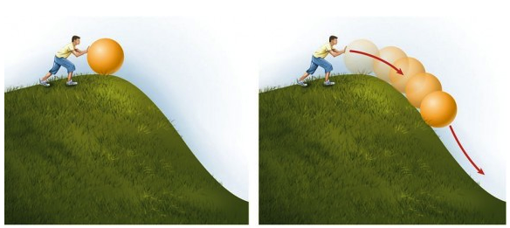
Potential Energy – This is the energy that is stored and can be used later. Usually due to height
Kinetic Energy – energy due to movement

Renewable – These are the resources that can be used again and again. (Ex. Trees, water, sunlight, wind)
Non-renewable – These are resources that are not reusable. Once you use them once they are gone! (Ex. Oil, gas, coal)
Energy transformations – the process of changing from one form of energy to another (Ex. a ball rolling down hill changes potential energy to kinetic energy)
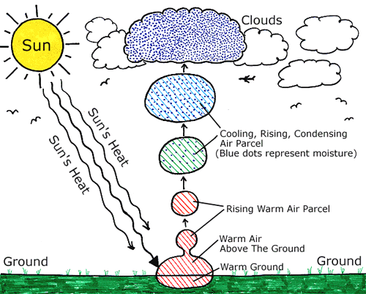
Conduction – Energy is changed by direct contact (this even occurs when air touches your skin)
Radiation – Energy is transferred by waves of energy moving out
Convection - The motion of molecules transfers Energy (hot air goes up, cool air moves down)
⬅ Cloud Formation – 1. Sun warms the water on the ground. 2. Water evaporates and rises. 3. Water cools and condenses into clouds. The water sticks to dust and particles in the air
Water - Solid (ice), Liquid (water), Gas (water vapor)
Water is essential to all life. Water is the universal Solvent, due to its polarity. H₂O. Water is bi-polar!
Cohesion/Adhesion – water likes to stick together whenever it can (hydrogen bonds)
Tools to Measure Water Quality
Secchi Disk – A circular disk that is used to measure water transparency pH stripes – Measure pH of water
Turbidity – The cloudiness or dirtiness of water in the sample. Thermometer – Measure temperature of water

Physical weathering – the breakdown of rocks and soil through direct contact with elements
Chemical weathering – involves the breakdown of chemicals on rocks and soil
The SUN! – All energy on our planet comes from the sun in one-way or another. It is a star in the center of our solar system. The sun is constantly producing nuclear energy (fusion). Drives all climate and weather.
Moon – The moon is responsible for the tides in the ocean. Pulls all the water on earth to certain places depending on the moons position. Rotates around the Earth and has 4 phases
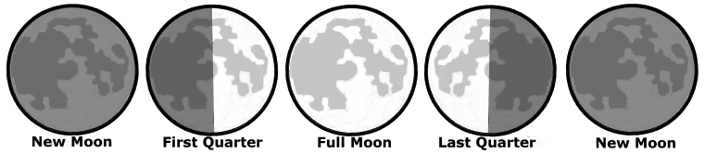
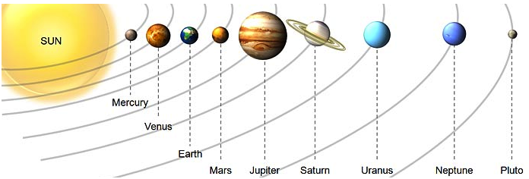
Earth – The only planet around that is in the “goldilocks zone” (not to hot, not to cold) Earth has water in all of its forms and all elements needed for life. Earth is tilted on its axis and this is the reason for seasons.

The size and distance between planets is massive. There are hundreds of thousands of miles between each one. The sun is the largest in our solar system. Order - MVEM & JSUN
Gravity – The natural phenomenon in which all physical bodies are attracted to each other. Gravity gives weight to things that have mass. It is what keeps your feet on the ground and pulls things from the sky down to the ground. The bigger something is, the more gravity it has.
Revolution – How long a planet takes to rotate around the sun (For the earth it is 365 days)
Rotation – How long the planet takes to rotate around its own axis
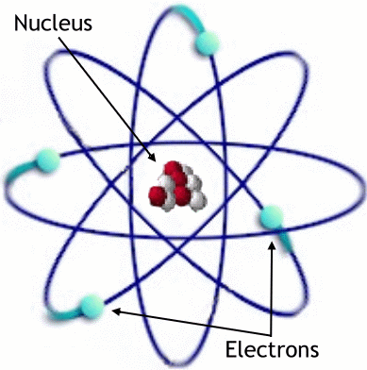
Matter – Everything is made up of matter. Anything that takes up space is made up of matter
Atoms – Made up of Electrons, Protons and Neutrons. Has a Nucleus and outer shells
Electrons – Part of an atom, has a NEGATIVE Charge, circles the nucleus
Protons – Part of an atom, has a POSITIVE Charge, part of the nucleus
Neutrons – Part of an atom, has a NEUTRAL Charge, part of the nucleus
Elements – Is pure chemical substance made up of only one type of atom

Bonds – The way elements connect together - Covalent, Ionic, hydrogen
Covalent Bond – Atoms share electrons (they covet them so much they can’t give electrons up)
Ionic Bond – Atoms will give up an electron to another atom so that one has an extra and one is missing an electron
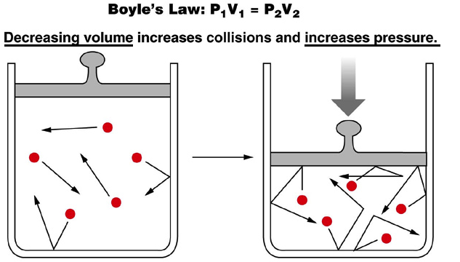
Compounds – A mixture of 2 or more different elements
Air – Made up of Oxygen (21%) Nitrogen (78%) Carbon Dioxide, Argon, and other trace elements (1%)
Pressure – The amount of matter in a given area. The more matter in that area, the higher the pressure.
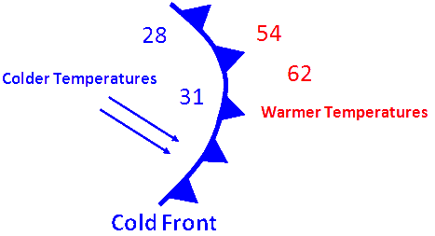
Temperature – Measurement of thermal energy (Celsius, Fahrenheit, Kelvin)
Humidity – The amount of water vapor in the air.
Altitude changes – The higher up in the atmosphere you go the less dense the air is. That is why it is hard to breath at the top of the mountain and why a plane is pressurized to keep your ears okay
Atmosphere – The protection from space, not all planets have one.
Weather maps – you need to be able to recognize how it works (Fronts, temps,etc)
Fronts – Cold or Warm – Show which direction the front is moving, where two air masses meet. (Pointy = cold, rounded = warm)
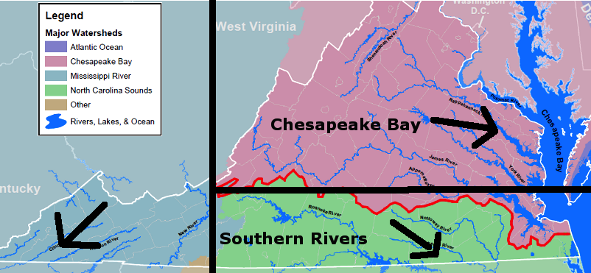
Watersheds – All the water that falls on land eventually flows out into the ocean -from small streams, to rivers and then out to the ocean. Water that falls in VA goes one of THREE places.
1. Western Virginia flows down to the Gulf of Mexico.
2. Southern Virginia flows down to the North Carolina Sounds.
3. Northern Virginia flows to the Chesapeake Bay.
Most of the United States water ends up flowing to the Gulf of Mexico.

Cell Theory – States that all organisms are made up of one or more cells, Cells are the basic unit of life, and cells come from cells that already exist.
Biogenesis – The theory that living things come only from other living things (Correct Theory)
Spontaneous Generation - The theory that living things come from non-living things (Incorrect Theory)
Compound Light Microscope – The fancy words for the microscopes you use in class
Eukaryotic Cells – Cells that have a Nuclear Membrane
Prokaryotic Cells – Cells that do NOT have a nuclear membrane

Mitosis – The process in which the cell divides into two exact copies
Prophase – “Prepare” – The genetic material bundles up and forms chromosomes and the nuclear membrane break down. The centrioles move to the poles of the cell.
Metaphase - “Middle” – The chromosomes line up in the middle of the cell. The centrioles attach to the chromosomes
Anaphase – “Apart” - The chromosomes are ripped apart and 1 set of each chromosomes move to each side
Telophase – “Two” – The cell begins to split into two and the nuclear membranes start to reform

Cytokinesis “Cut” – The cell finally splits apart. This results in two exact copies of the original cell
“Mitosis makes my toeses Meiosis made me”
Interphase – The cell remains in interphase for most (99%) of the time it is alive. Only when it gets the signal does it start Mitosis
Meiosis – Is slightly different than Mitosis – PMATs twice & makes four sex cells (sperm, eggs)

CELL ORGANELLES (*Only in plants)
Cell Membrane – Outer Boundary of the cell that allows only certain materials to pass into and out of the cell
Cytoplasm – Gel-Like material inside the cell membrane and outside the nucleus
Endoplasmic Reticulum – Folded membrane that moves materials around in the cell (Transportation)
Mitochondria or Mitochondrion – Breaks down food and releases energy (Cell Powerhouse)
Nucleus – Directs all cell activities (the brain of the cell)
Vacuoles – Storage tanks for the cell (much bigger in plants, but still present in animals)
Lysosome – Contain chemicals that digest wastes and worn-out cell parts as well as break down food
Ribosomes – Where all the protein is made
*Cell Wall – Rigid Structure made of cellulose that supports and protects the plant cell; Found outside cell membrane
*Chloroplast – Organelles in plant cells that change light energy into chemical energy in the form of sugar (glucose) - also in some protists like the Euglena
*Chlorophyll – Green pigment in plant cells that traps light energy, which is then used to produce food for
the plant cell

Movement of materials across a membrane
Active Transport – Energy requiring process that can “carry” a substance into a cell
Passive Transport – Movement of a material across a cell without the use of energy (Water does this)
Diffusion – Movement of molecules from an area where there is a HIGH concentration to LOW concentration (think about water behind a dam and what happens if the dam is taken away).
Osmosis – Diffusion of WATER into and out of the cell (moves through the cell membrane). Water is moving constantly
Equilibrium – The state where molecules of a substance are spread out EVENLY throughout a space. Equal
Selective Permeability – The property of a cell membrane that allows some materials to pass through while keeping other materials out. Like the Security guy at the club that only lets the pretty ladies in.
Digestion – Mechanical and chemical breakdown of food into small molecules that cells can absorb and use
Irritability – The property of living organisms that permits them to react to stimuli
Metabolism – Total of all chemical activities of an organism that enable it to stay alive, grow and replicate.
Atom – the basic unit of ALL things
Cell – The smallest unit of an organism (living thing) that can perform life functions
Tissue – Group of similar cells that work together to do a job. They form Organs
Organ – Structure, such as the heart, made of up different types of tissues that work together to form systems
System – Organs work together to form a system such as the digestive system – requires several organs like the stomach, small intestines, brain, etc. Systems form a fully developed Organism.

Endocytosis – Process by which the cells transport stuff INTO the cell
Exocytosis – Process by which the cells transport stuff OUT of the cell

Atom- Smallest unit of matter
Element – Made up of one kind of atom
Compound – Substance created when two or more atoms chemically combine

DNA – (DeoxyriboNucleic Acid) Molecules that is the master copy of an organism’s information code.
Nitrogen Base Pairs - A pairs with T, C pairs with G
Adenosine, Thymine, Cytosine, Guanine
Gene – Section of DNA one a chromosome that contains instructions for making specific proteins
Genetics – The study of how traits are inherited through the actions of alleles
Genome – The entire DNA in one cell of an organism
Genotype – The genetic makeup of an organism or allele combinations (Ex. Tt, TT, tt)
Phenotype – The physical trait of an organism that you actually see (Ex. Blue Eyes, Brown Hair)
Heredity – Passing of traits from parents to offspring
Clone – an organism that is genetically identical to the organism from which it was produced
Selective Breeding – Process of selecting a few organisms with desired traits to serve as parents of the next generation (This is why we have tiny dogs or those gross cats)
Mutation – Any permanent change in an organism’s genetic material (Drives Evolution)
Allele – Each form of a gene; a different form a gene may have for a trait. Two forms are Dominant and Recessive
Dominant – A trait that always shows up in the organism or covers up another trait
Recessive – A trait that only shows up in an organism when it is paired with another Recessive trait. Gets overruled by Dominant traits
Heterozygous – Traits that are opposite (Tt) Think Heterosexual, one girl, one boy
Homozygous – Traits are the same (TT, tt) Think Homosexual, two boys or two girls
Chromatin – Heredity material made up of proteins and DNA
Chromosome – rod-shaped structures made up of condensed DNA that are located in the nucleus of every cell in an organism
Nucleus (Inside the cell) ➔Cell Chromosome DNA Molecule Nitrogen bases
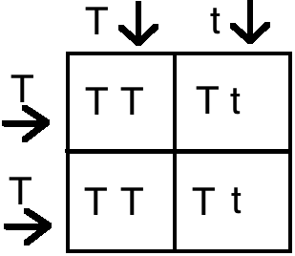
Punnett Squares

  letters are at the top, put them in the 2 boxes underneath
If the letters are on the side, put them in the 2 boxes on the right

Remember, each box with a capital letter = 25% chance that the trait will be dominant. Add up the boxes with a capital letter (all of them in this example) and then you will know the % of dominant and % recessive.
DOMINANT vs. recessive… DOMINANT ALWAYS WINS.

Adaptation – Any variation that makes an organism better suited to its environment
Evolution – Change in inherited characteristics over time
Extinction – No more Organisms of that species
Fossil – Remains of once living organisms. This is the main evidence of Evolution
Natural Selection – Organisms with traits best suited to their environment are more likely to survive and reproduce; includes concepts of variation, overproduction, and competition
Population – a group of organisms of the same species living in the same area at the same time
Species – similar organisms that can successfully make babies
Trait – A genetically determined characteristic or condition
Variation – Inherited trait that makes an individual different from other members of the same species and results from a mutation in the organism’s genes

LEAST SPECIFIC
Dear - Domain – The largest categories of organisms base on cell type (Includes Archae, Bacteria, Eukaryota).
King – Kingdom – Largest category in each Domain (Includes Animal, Plant, Protista, Fungi)
Phillip – Phylum - Animal Kingdom includes 6 Phylum’s:
Annelids – Segments (Worms)
Arthropods – Exoskeleton (Bugs, Lobsters)
Chordates – Anything with a backbone (Humans, Tigers, Whales)
Cnidarians – Radial Symmetry and Stingers (Jellyfish, Sea Anemone)
Echinoderms – Spikey Skin (Sea Star, Sea Cucumber, Sea Urchin)
Mollusks – Soft Body (Squid, Snails, Clams)

Plant Kingdom includes 4 Divisions:
Mosses – Seedless, Non-vascular (Moss)
Ferns – Seedless, Vascular (Ferns)
Conifers – Gymnosperms - Cones and Needles (Pine Tree)
Flowering Plants – Angiosperms – Flowers (Rose, lily)
Came – Class – Phylum’s get broken down into Classes
Over – Order – Classes are broken down into Orders
For – Family – Orders are broken down into Families
Good – Genus – A group of Similar Organisms. Broken down into species
Spaghetti – Species – Organisms that are of the same species can reproduce and make viable offspring
MOST SPECIFIC

Organisms are named with their Genus and species (Example Homo sapien) and it’s always in italics. Only the first letter is capitalized! This is called Binomial Nomenclature. Also Latin is the language used.

Species Diversity – Variety of plants, animals, and other organisms

Photosynthesis – The process that allows plants to turn light energy (Sun) into chemical energy (Glucose). (Endothermic) Think about what you know plants use and what they put out. It is the opposite (chemically speaking) of Respiration.
6 CO₂ + 6 H₂0 + Light Energy C₆H₁₂O₆ + 6 O₂

Respiration – The process that every organisms uses to change Chemical Energy (Glucose) into Energy organisms can use to think, move and live. (Exothermic) It is the opposite (chemically speaking) of Photosynthesis

C₆H₁₂O₆ + 6 O₂ 6 CO₂ + 6 H₂O + Energy

Raw Materials – (also know as reactants)The materials that go into the processes
Products – The materials that come out of the processes.
Think about a cake. Raw Eggs, Raw milk, and other ingredients (raw materials) go into pan. They are baked (light energy) and out comes a finished cake (product) that you could potentially sell.
Angiosperm – A plant that produces flowers and seeds in fruits (apple trees, squash, roses, grasses)
Gymnosperm – Vascular plant that produces “naked” seeds that do not have protective coverings. (pine tree)
Vascular – Long, tube like cells in which water and nutrients are transported through
Non-Vascular – plant group containing mosses. Plants lack vascular tissue and can’t transport water and nutrients

Producer – An organism that is able to create its own energy
Consumer – An organism that consumes nutrients and has to actively seek out its food
Decomposer – Breaks down anything that is dead or dying
Heterotrophic – Can’t create its own food and needs to find it (consumers)
Autotrophic - Can create its own food (producers)
Abiotic- Not Alive (Inorganic) Biotic – Alive (organic)
Competition – The demand by two or more organisms for limited environmental resources, such as nutrients, living space, or light
Cooperation – Joint operation or action (wolves hunting as a pack)
Niche – The role of organisms in an ecosystem
Community – All the populations of different species that live in the same place at the same time and interact with each other.
Population – A group of the same species living in the same area at the same time.
Ecosystem – All the living organisms that live in an area and the nonliving features of their environment
Biome – A group of ecosystems with similar climates and organisms

Desert – A biome in which the annual evaporation is greater than the amount of precipitation (very dry)
Rainforest – A biome that is tropical woodland with annual rainfall of at least 100 inches and has large leaved evergreen trees that form a continuous canopy
Taiga – A biome that is a cold region of cone-bearing, evergreen trees, including pine, hemlock and others. Also called a Boreal forest
Temperate deciduous Forest – A Biome containing deciduous trees, which lose their leaves in the fall. This is Virginia.
Grassland – A biome that typically gets 25 to 75 cm of rain annually and dominant vegetation is grasses (Prairie, savannah)
Tundra – A biome that is Cold, dry, treeless region where winters are 6-9 months long

Marine – Salt water
Estuary – Where freshwater mixes with salt water (brackish water) (Where the James river flows into the Chesapeake Bay)
Terrestrial – Living or growing on land; not aquatic
Symbiosis – A close relationship between two organisms that live together
Commensalism – A symbiotic relationship that benefits one partner, but does not harm nor benefit the other (Sharks and Remoras)
Mutualism – A symbiotic relationship in which both organisms benefit (Clown Fish & Sea Anemone)
Parasitism – A symbiotic relationship that benefits the parasite, but harms the parasite’s partner (Tape worm & Dog)
Host – The animal or plant in or on another organism lives
Parasite – An organism that grows, feeds, and is sheltered on or in a different organism while contributing nothing to the survival of its host.
Predator – An organism that lives by preying on other organisms
Prey – An organism hunted or caught for food
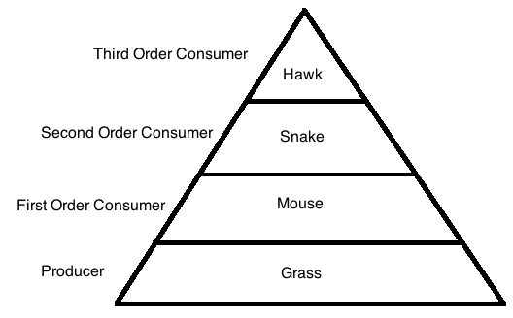
Carnivore – Animal that eats ONLY other animals or the remains of other animals
Herbivore – Animal that eats ONLY plants
Omnivore – Animal that eats plants AND animals
Energy pyramid – The model that demonstrates relationships among producers and consumer ➔➔➔

Evaporation – When water changes from liquid to gas (water vapor)
Condensation – When water changes from gas (water vapor) to liquid
Precipitation – Any water that falls from the sky (snow, rain, sleet, hail)

Behavior – The way an organism acts towards its environment
Habitat – Where an organism lives and provides food, shelter, moisture and the correct temperature
Dormancy – The condition of biological rest or inactivity where growth and development slow way down
Hibernation - Slowing activity during the winter; especially the slowing of metabolism
Migration – Instinctive seasonal movement of animals to find food or reproduce
Energy Pyramid – Diagram that shows the amount of energy available at each feeding level in an ecosystem
Nitrogen Fixation – Process of changing free nitrogen in the air to a form of nitrogen that plants can use. Bacteria live in nodules on the roots of legume plants fix the nitrogen
Phototropism – The tendency of plants (especially seedlings) to grow towards the sun
Tropism – A plants response to stimulus
Phototropism – Plant grows towards the sun
Thigmotropism – Plants response to touch
Gravitropism – Roots grow towards gravity
Eutrophication –
1. Algae grows like crazy due to an excess of needed nutrients. (Animal waste run off, fertilizer, etc.)
2. Algae bloom blocks out the sun and the plants at the bottom of the lake that need sun die.
3. Decomposers then multiple like crazy because there is so many dead organisms, they use up all the oxygen in the water.
4. All of the fish and other water organisms die. (no oxygen in the water for respiration)

Acid Rain – Rain or snow with a pH below 5.6 that washes valuable nutrients from the soil, leading to the acidification of lakes and ponds and the death of organisms
Air Quality – A measurement of pollutants in the air
Biodiversity – The number of different species in an area
Global Warming – An increase in the average temperature of the earth’s atmosphere due to increased levels of carbon dioxide and certain other gases in the atmosphere
Ozone Depletion - The thinning of the Earth’s ozone (O₃) layer due to chlorofluorocarbon (CFC’s)
Soil depletion – overuse of soil by farming, causing desertification (non-renewable resource)

Theory of matter - all matter consists of tiny particles called molecules. These particles are constantly moving and bouncing off each other like ping pong balls.
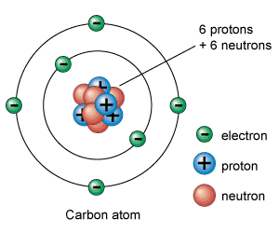
Acids – Any compound that increases the number of hydronium ions H₃0⁺ pH less than 7 (H+)
Bases – Any compound that increases the number of hydroxide ions OH⁻
(Oxygen and Hydrogen bonded together) pH more than 7 (OH)
Salts – formed when positive ion of a base and a negative ion of an acid are combined.
Physical Properties – Can be observed or measured without changing the matters identity (Ex. The car is yellow – you can change this by painting the car – reversible change.)
Chemical Properties – Describe matter based on its ability to change into new matter that has different properties (Ex. When wood is burned, ash and smoke are created (irreversible change)

Atomic Structure - all the atomic elements make up the ⬇Periodic Table ⬇
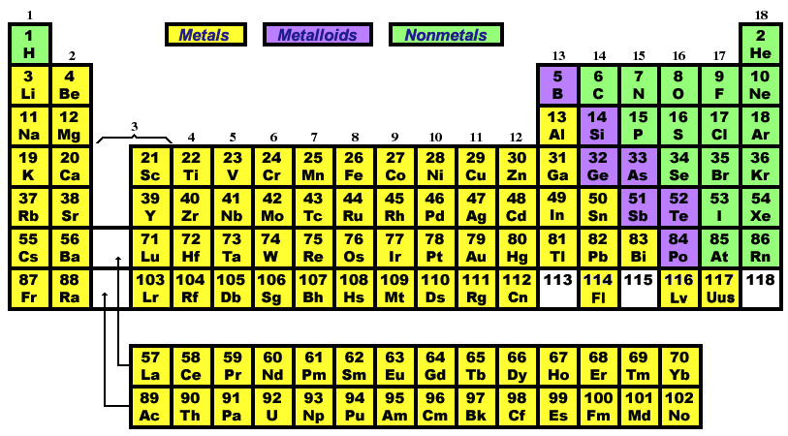
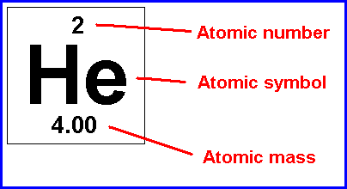
Atomic Symbol – The letters that stand for the element
Atomic Number – The number of PROTONS
Atomic Mass – The mass of the element

Chemical Families or groups– go up and down (vertical) – determined by the number of valence electrons. For example the elements in family #1 have one valence electron. (Careful! Family 13 has 3 valence electrons and 18 has 8 valence electrons)
Periods – go side to side (horizontal) and have the same number of electron “shells” or energy levels.
Octet Rules – The tendency of an element to either gain or lose electrons in order to have 8 electrons in the outer energy “shell”
Classification of elements – We use similarities of the properties that elements demonstrate
Metals – Shiny, conduct heat energy and electric current.
Metalloids – Are a mixture of metals and non-metals, demonstrate properties of both. Located on the “stair step” in the periodic table
Nonmetals – Do not conduct heat or electric current, dull in appearance
Ionic – A bond that forms when electrons are transferred from one atom to another atom – A metal and a non-metal for example NaCl- Na is Sodium (metal) and Cl is Chloride (non-metal)
Covalent bonding – A bond that forms when atoms share one or more pairs of electrons. Example - Two non-metals bonding – H₂O, H is Hydrogen and O is oxygen, they share the 1 valence electron Hydrogen has and the seven valence electrons Oxygen has in order to fill both outer electron shells.
Conservation of mass- mass cannot be created or destroyed- but can be converted. (Except in a Nuclear Reaction)

Chemical Equations - A chemical sentence that shows a chemical reaction. The same number of elements must exist on BOTH SIDES of the “yields” (arrow) in an equation.
6 CO₂ + 6 H₂0 + Light Energy C₆H₁₂O₆ + 6 O₂
To Balance an equation- list the number of each element on each side of the arrow. Balance by adding coefficients (NEVER CHANGE THE SUBSCRIPT) until the same number of elements exists on both sides.
Coefficient – number in front of the compound in an equation.
Subscript- the number below the element – sub means below.

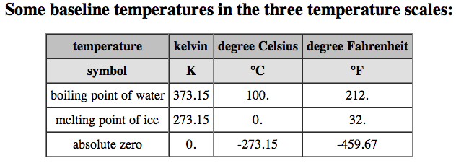
Temperatures to Know
Absolute Zero – The coldest possible temperature – 273 Degrees Celsius and -459 Degrees Fahrenheit…. So really, really cold. All motion stops, even the atoms
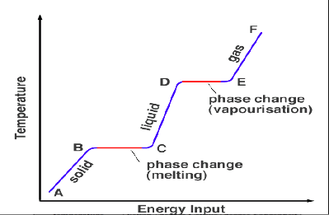
Phase Change- during a phase change- melting, freezing, evaporating-
The temperature of the substance STAYS THE SAME DURING THE CHANGE.

Types of Energy – (The ability to do work)
Potential – The energy an object has because of its position. (Ex. Stretched Bow = Elastic Potential Energy, Ball at the top of the hill = Positional Potential Energy)
Kinetic – Energy of Motion (Ex. Anything that is moving)
Mechanical – The total energy of motion and position of an object (potential and kinetic energy) (Ex. Machines)
Chemical - The energy of a compound that changes as its atoms are rearranged. (Ex. Burning fuel, digesting food Respiration in the Mitochondria)
Electrical – The energy of moving electrons. (Ex. plugging something in moves electrons to different parts of the machine) (Types-Alternating Current AC and Direct Current DC)
Thermal – Heat, is all of the kinetic energy due to motion of the particles that make up an object (the hotter something is the more thermal energy it has, as the particles are moving faster)
Nuclear – The energy that comes from changes in the nucleus of an atom. Fission (splitting an atom- this is how Nuclear Bombs are made.) & Fusion (joining together nuclei- like the Sun – two Hydrogen molecules smash together, fuse and make a Helium molecule and releasing HUGE amounts of energy)

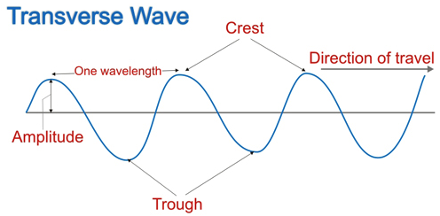
Wavelength – The distance between any two crests of compressions next to each other in a wave. Made up of frequency, speed and amplitude.
Frequency – The number of waves produced in a given amount of time. (Hertz) Higher frequency means more energy
Speed – The speed in which the wave travels
Amplitude – related to its height. The larger the amplitude the taller the wave is. Crest – The peak of each wave
Trough – The bottom of each wave

⬇Longitudinal Wave⬇
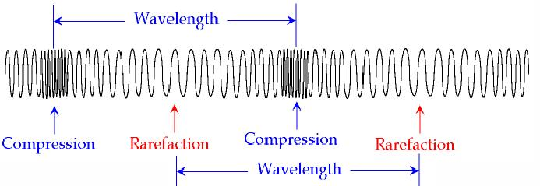

Rarefaction – When a wave spreads out the wave length increases
Compression – When a wave compresses and wavelength decreases

Light – A type of energy that travels as a wave. Light does not require matter through which to travel. It is an electromagnetic wave. Different frequencies produce different colors and effects.
Lenses – A transparent object that forms an image by refracting or bending light. Convex, concave
Resonance – When an object vibrating at or near the resonant frequency causes the second object to vibrate
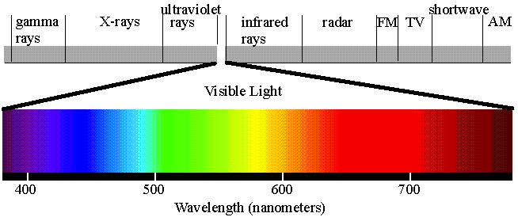
Electromagnetic spectrum – long wave to short wave
Newton’s laws of Motion
- An object at rest will remain at rest. An object in motion will remain in motion at constant speed and in a straight line unless acted upon.
- The acceleration of an object depends on the mass of the object and the amount of force applied.
- When a force is exerted on an object an equal and opposite force is exerted on the first object
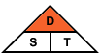
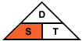
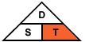

Time = Distance/Speed Speed= Distance/Time Distance = Speed X Time
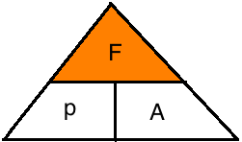
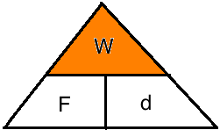

Work = Force X Direction Force= Power X Acceleration
Use the triangles above to help solve problems involving speed, acceleration, force, work, and power.
Caution: You may need to use more than one to answer a single problem.

Speed – Distance traveled by an object divided by time taken to travel the distance. Speed = Distance/Time
Velocity – Rate of change of an objects position. Is constant only if speed and direction do NOT change
Acceleration – The rate at which velocity changes. Acceleration occurs if speed, direction or both change.
Force – A push or a pull. Net force is the combination of all forces acting upon an object. Measured in Newtons
Work - When a force causes an object to move in the direction of the force. Work is basically the transfer of energy. Work = Force X Direction
Power – The rate in which energy gets transferred. Power=Work/Time
Mechanical Advantage – the number of times the machine multiplies force. Input Force vs. Output Force
Efficiency – A comparison of a machines work output vs. work input. The less work a machine has to do to overcome friction the more efficient it is. Power – The rate in which energy gets transferred. Power=Work/Time
Static electricity – The electric charge at rest on an object
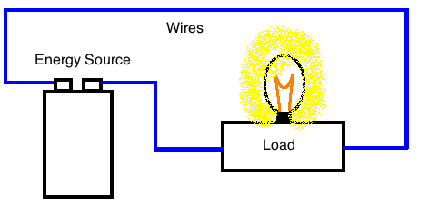
Current electricity – the rate at which charges pass a given point. The higher the current is, the greater the number of charges that pass the point each second.
Circuits – A complete, closed path through which electric charges flow. Needs 3 things, an energy source, wires and a load. (Load = the thing that is receiving the electricity) Two types- Parallel and Series
Magnetic field - magnets have specific magnetic fields. The Earth has a magnetic
field (South and North poles). Opposites attract, Same repels.
Electromagnets – A solenoid wrapped around an iron core. Can be turned on an off with an electric current. (Ex. Doorbell)
Motors – Electric motor turns electrical energy into mechanical energy
Turbine – A machine that converts kinetic energy of moving liquid, or air to mechanical energy. (Think windmills and water dams)
Electric Generators – Uses electromagnetic induction to change mechanical energy into electrical energy.

Conductors – A material in which charges can move easily. Most metals are conductors, the electrons can move freely
Semiconductors – A substance that conducts electric current better than an insulator, but not as well as a conductor
Insulators – A material in which charges cannot move easily. The electrons can NOT move freely (Ex. rubber, glass, wood, air.

NAMES YOU NEED TO KNOW!!!
Charles Darwin – Came up with the theory of evolution. Species gradually change over time
Watson & Crick – Discovered the structure of DNA (A,T,C,G nitrogen base pairs)
Mendel – The Monk that had a pea plant garden. He tracked the traits of the plants and realized that they were dependent on the previous generation and probability. Punnett squares.
Rosalind Franklin – used an x-ray to figure out DNA is a Double Helix
Louis Pasteur – Scientist who figured out boiling kills bacteria using nutrient broth. Pasteurization is named for him.
Francesco Redi – Disproved Spontaneous Generation
Aristotle – The first Scientist to create a classification system (run, fly, swim)
Robert Hooke – The first person to observe cells, looked at cork under a microscope
Linnaeus – Came up with the classification system we use today
Dalton – came up with original atomic theory – 1. All substances are made up of atoms, atoms cannot be created, divided or destroyed. 2. Atoms of the same element are exactly alike. 3. Atoms join with other atoms to make new (different) substances.
Thomson – Discovered that there are small particles INSIDE the atom. He called it the Plum Pudding Model because he thought the atom was a big blob of positive with negatives all through it. Those negative were electrons. The atom could be divided even smaller.
Rutherford – Used his gold foil experiment to show a new model of the atom – mostly empty space – small positive nucleus
Bohr – Realized that electrons moved around the nucleus in certain paths or energy levels (think about planets around the sun) Created the Bohr Model of the Atom – the one we draw in class

This is a lot of material to remember. Please stay after school on Mondays to study for the SOL.
Do Not try and study for the SOL in just a few days.
Have someone call the vocabulary out to you and you will receive extra credit!

